Title of Email: "See You Tomorrow as We Celebrate 25 Years Together"

Dear [name],
The wait is almost over!
We are excited to welcome you tomorrow to the PEOPLElogy 25th Anniversary Celebration as we commemorate 25 years of growth, innovation, partnerships, and success.
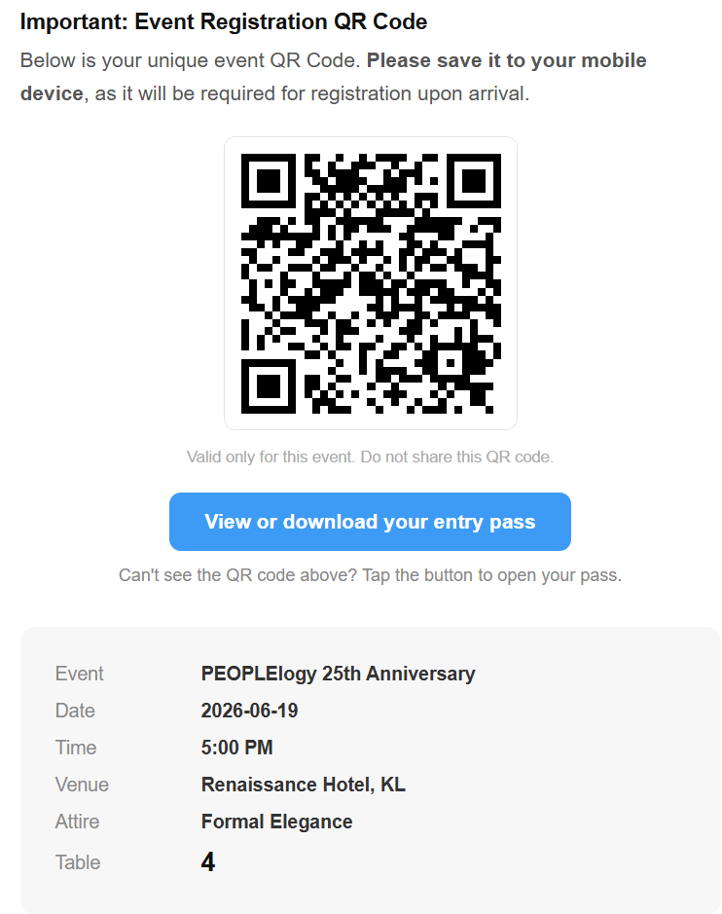
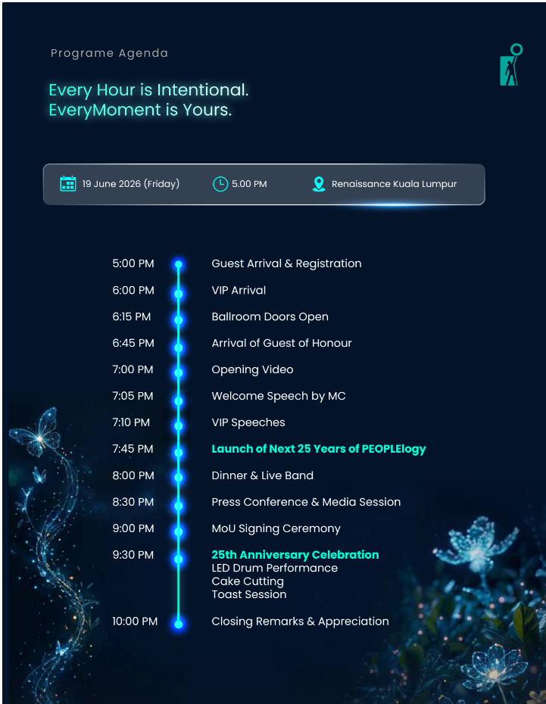
We encourage you to arrive early to enjoy the networking session and cool experiences we have in store for you.
We look forward to celebrating this special milestone together and creating memorable moments with you.
Safe travels, and see you tomorrow!
Warm regards,
PEOPLElogy Berhad

